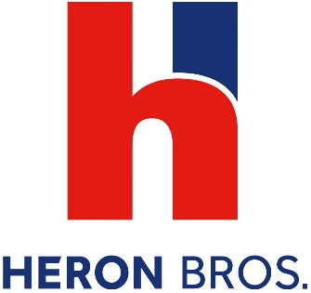

Heron Bros is an award winning construction and property development company which operates throughout the UK, Ireland and Europe.
We currently have a number of vacancies in Draperstown, Magherafelt for:
Apprentice Joiners (Architectural/Bench)
The successful candidates must be aged between16-24 and will be involved in a variety of duties, and receive full training on:
- Working in a Joinery workshop to make shaped timber and make parts such as doors, and windows (bench joiner)
- Using tools required for joinery duties
- Fitting sub-assemblies
- Cutting to measurements
- Reading designs and following instructions
- Working professionally in factory premises.
You must have or expect to achieve 4 GCSEs A*-C (9-4) or equivalent to include Mathematics and English.
To Apply:
Please forward a completed CV by email before Monday 9th August 2021 to:
jobs@heronbros.com

Heron Bros are an Investors in People Platinum Award winning business which recognises our investment and development in our People. A Global Employer of the Year Winner 2020 and Business in the Community Responsible Business Winner, Heron Bros provide first-class training and development opportunities. An Apprenticeship with Heron Bros is the best choice.
Heron Bros, Heron Team, Heron Future

