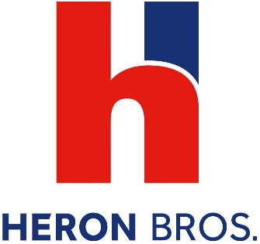

Heron Bros is an award winning construction and property development company which operates throughout the UK, Ireland and Europe.
We currently have a vacancy in Draperstown, Magherafelt for:

Apprentice Light Vehicle Technician

The role covers the day to day maintenance of vehicles along with the diagnosis and repair of damage or faults across a variety of vehicles.
We are seeking someone aged between 16-24 who has a keen interest and enthusiasm for working with automotive vehicles, who is honest, trustworthy and willing to learn. You will have a positive attitude and work ethic along with the ability to work in a team in a busy workshop environment.
You must have or expect to achieve 4 GCSESs A*-C (9-4) or equivalent to include Mathematics and English.
The role will be interesting and varied and the experience received while training 'on the job' will be invaluable for your future career. The Apprenticeship will lead to you will becoming a fully qualified Light Motor Vehicle Technician.
To Apply:
Please forward a completed CV by email before Monday 9th August 2021 to:
jobs@heronbros.com

Heron Bros are an Investors in People Platinum Award winning business which recognises our investment and development in our People. A Global Employer of the Year Winner 2020 and Business in the Community Responsible Business Champion, Heron Bros provide first-class training and development opportunities. An Apprenticeship with Heron Bros is the best choice.
Heron Bros, Heron Team, Heron Future

