Covid -19 Risk Assessment – Pathway out of Restrictions

Assessed by: | Kyle Leckey | Task | Close Contact/Essential Curriculum Delivery
Location: | All Sites | Personnel: | NRC Staff & Students
Date: | Monday 19th April 2021 | Reference: | COVID/Apr21

Introduction
This risk assessment acknowledges the addendum to version 1.3 of the framework for safe resumption and will assist with setting out a range of protective
measures to control contraction of the coronavirus via persons, objects or surfaces and reduce risk to the lowest reasonably practicable level to allow learners
to attain their planned level of attainment or qualification for 2020/21.

In order to safeguard the health and well- being of all, it is mandatory for all learners, staff, and visitors to wear face coverings at all times whilst on campus, unless they have a medical exemption. The college will continue to promote distance learning to the maximum extent possible.

Summary of Protective Measures - (w/c 19th April 21 – essential training & assessment) (w/c 26th April 21- close contact training assessments).

- Mandatory for all learners, staff, and visitors to wear face coverings at all times whilst on campus, unless they have a medical exemption;
- Increased frequency of handwashing and surface cleaning to twice daily across all close contact areas;
- Increased ventilation including use of regular breaks;
- Allocation of equipment and product for the sole use of individual learners;
- Where social distancing guidelines cannot be followed in full, further mitigations will include keeping the activity time as short as possible, learners and staff working in close proximity to wear a visor/goggles, type 2 face covering, apron and where possible gloves and restricting engagements for close contact training and assessment within the designated class group by using a consistent pairing system.

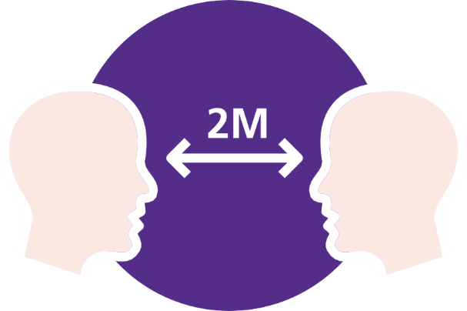
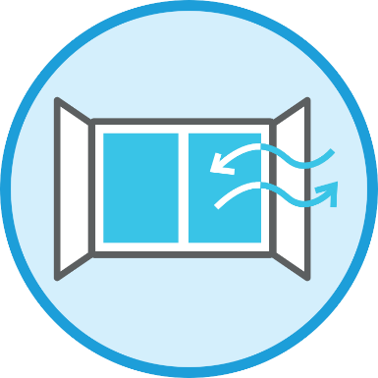

Risk Matrix - calculated by multiplying the likelihood against the severity.
Risk calculated after consideration of current controls

Severity  Likelihood | Trivial  (1)  Cut/Nip | Minor  (2)  First Aid | Lost Time (3)  A&E | Major (4)  Hospital Stay | Fatality (5)  Fatal
Remote (1) - Not likely to happen | 1 | 2 | 3 | 4 | 5
Unlikely (2) – Unlikely harm will occur | 2 | 4 | 6 | 8 | 10
Possible (3) - Possible harm will occur | 3 | 6 | 9 | 12 | 15
Likely (4) - Likely harm will occur | 4 | 8 | 12 | 16 | 20
Very Likely (5) – Very likely harm will occur | 5 | 10 | 15 | 20 | 25

Low Risk 1-4 | Medium Risk 5-9 | High Risk 10-25
Low risk is largely acceptable but subject to periodic review or when significant change to processes. | Medium risk should only be tolerated for the short term whilst further control measures to mitigate the risk are being planned and introduced. | High risk activities should cease immediately until further control measures to mitigate the risk are introduced.

Identified Hazard | Who may be affected | Control Measures in Place | Risk  Rating | Additional Controls | Action | Completion Date
Coronavirus Risk of contraction via persons, objects or surfaces during college occupancy. | Staff, Students & Visitors | Covid Awareness/Compliance  - Learners will be taken through a revised induction to remind them of all COVID-19 measures in college including on-site protocols, hand washing, navigation within the building, rules for shared areas/ key facilities, and measures applicable to close contact training.  - Staff to refresh on previous induction training.  - Staff & students remain at home if presenting any Covid symptoms i.e. high temp, continuous cough or anosmia.  - Visitor assurance statement to be completed for all visitors required to be on-site. | 1x5=5  Medium | - All occupants to follow Covid measures identified within this risk assessment. | All Occupants | On-going good practice
 |  | Sanitisation  - Increased frequency of handwashing and surface cleaning to twice daily across all close contact environments.  - Sanitisation stations & associated signage provided at entrance points and throughout the college.  - Regular touch point cleaning in place.  - Sanitiser & wipes provided in all rooms. | 1x5=5  Medium | - Please ensure hand sanitisation on entering and exiting the college.  - Please wipe down shared surfaces when finished such as desk, benches, keyboard, mouse etc. | All Occupants | On-going good practice
 |  | Social Distancing  - When in contact training  environments, everyone will make  every reasonable effort to comply with  the 2 metres social distancing  guidelines set out by the government  when not involved in close contact  procedures.  - Room configuration in place to ensure compliance with 2m social distancing.  - Restricting engagements for close  training and assessment within the  designated class group by using a  consistent pairing system.  - Where social distancing guidelines  cannot be followed in full, further  mitigations will include keeping the  activity time as short as possible. | 1x5=5  Medium | - Promote 2m social distancing at  all times. This includes occupancy of corridors, public areas etc. | All Occupants | On-going good practice
 |  | Face Coverings/PPE  - Mandatory for all learners, staff, and visitors to wear face coverings at all times whilst on campus, unless they have a medical exemption (reusable & disposable coverings available from reception).  - Where social distancing guidelines cannot be followed in full, further mitigations for close contact work will include learners and staff wearing a visor/goggles, type 2 face covering, apron and where possible gloves. | 1x5-=5  Medium | - Please follow PPE requirements to reduce risk to the lowest reasonably practicable level. | All Occupants | On-going good practice
 |  | Ventilation  - Windows & doors opened to promote natural air circulation.  - Further mitigations will include keeping the activity time as short as possible.  - Room configuration to comply with 2m social distancing.  - Reduced occupancy through room configuration and regular breaks controls the risk of virus concentration build up. | 1x5=5  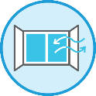  Medium | - Follow room configuration numbers and provide regular breaks to control the risk of virus concentration build up. | All Occupants | On-going good practice
 |  | Handling Goods/Materials  - Increased frequency of handwashing and surface cleaning twice daily across all close contact areas.  - Allocation of equipment and product for the sole use of individual learners.  - Cleaning in place before and following client learner use.  - Pick-up and drop-off collection points promoted rather than passing goods/equipment hand-to-hand.  - Equipment entering a person’s home is thoroughly cleaned, disinfected or sterilised before use and between clients.  - Sanitiser & wipes provided in all rooms. | 1x5=5  Medium | - Continue to avoid sharing of goods/items/materials and always use sanitisation/wipes provided. Continue to promote good handwashing practices. | All occupants | On-going good practice
 |  | Communication  - Risk assessment available for download on the staff intranet under the Coronavirus page.  - Pathway document issued to all departments for briefing to staff.  - Reminder issued to all students on safety measures.  - Regular staff communication via college network and media platforms. | 1x5=5  Medium | - All occupants to follow Covid measures identified within this risk assessment. | All Occupants | On-going good practice

