Covid -19 Risk Assessment – Stage 5 Confirmation (Pathway out of Restrictions)

Assessed by: | Kyle Leckey | Task | Return to Curriculum Delivery (Face to Face)
Location: | All Sites | Personnel: | NRC Staff & Students
Date: | Friday 13th August 2021 | Reference: | COVID/Aug21

Introduction
This risk assessment acknowledges the latest NI Executive announcement regarding Stage 5 of the pathway out of restrictions, effective from Monday 16th
August 2021. Stage 5 has enabled the removal of social distancing within the classroom environment. The Northern Regional College will continue with
setting out a range of protective measures to control contraction of the coronavirus via persons, objects or surfaces and reduce the risk to the lowest
reasonably practicable level to all occupants.

In order to safeguard the health and well- being of all, it is still mandatory for all learners, staff, and visitors to wear face coverings at all times whilst on campus, unless they have a medical exemption.

Mitigations contained within the Framework for the Safe Resumption of On-Site Educational Provision and Related Activity must remain in place and should still be adhered to. This includes, but not limited to the following:

- wearing face coverings at all times on campus;
- the continued use of good hand hygiene;
- maintaining 2 metre social distancing outside the classroom environment;
- ensuring that surfaces are regularly cleaned and sanitised;
- continuation of the agreed track and trace procedures; and
- continue with the provision of Lateral Flow Self Testing (LFT) for staff and students.
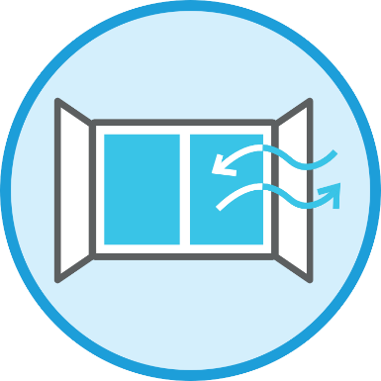
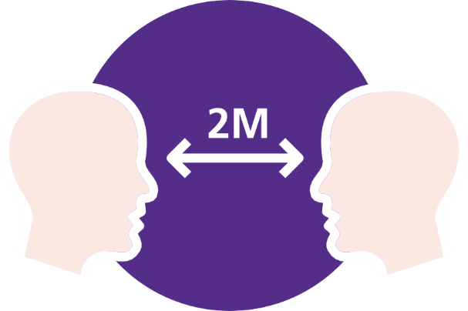

Risk Matrix - calculated by multiplying the likelihood against the severity.
Risk calculated after consideration of current controls

Severity  Likelihood | Trivial  (1)  Cut/Nip | Minor  (2)  First Aid | Lost Time (3)  A&E | Major (4)  Hospital Stay | Fatality (5)  Fatal
Remote (1) - Not likely to happen | 1 | 2 | 3 | 4 | 5
Unlikely (2) – Unlikely harm will occur | 2 | 4 | 6 | 8 | 10
Possible (3) - Possible harm will occur | 3 | 6 | 9 | 12 | 15
Likely (4) - Likely harm will occur | 4 | 8 | 12 | 16 | 20
Very Likely (5) – Very likely harm will occur | 5 | 10 | 15 | 20 | 25

Low Risk 1-4 | Medium Risk 5-9 | High Risk 10-25
Low risk is largely acceptable but subject to periodic review or when significant change to processes. | Medium risk should only be tolerated for the short term whilst further control measures to mitigate the risk are being planned and introduced. | High risk activities should cease immediately until further control measures to mitigate the risk are introduced.

Identified Hazard | Who may be affected | Control Measures in Place | Risk  Rating | Additional Controls | Action | Completion Date
Coronavirus Risk of contraction via persons, objects or surfaces during college occupancy. | Staff, Students & Visitors | Covid Awareness/Compliance  - Communication issued to both staff & students regarding the latest announcement.  - At the start of term learners will be taken through a revised induction to remind them of all COVID-19 measures in college including on-site protocols, hand washing, social distancing outside of the classroom environment etc.  - Staff are expected to refresh on previous awareness training.  - Staff & students remain at home if presenting any Covid symptoms i.e. high temp, continuous cough or anosmia.  - Visitor assurance statement to be completed for all visitors required to be on-site. | 1x5=5  Medium | - All occupants to follow Covid measures identified within this risk assessment. | All Occupants | On-going good practice
 |  | Sanitisation  - Increased frequency of handwashing and surface cleaning across all close contact environments.  - Sanitisation stations & associated signage provided at entrance points and throughout the college.  - Appointed staff carryout regular touch point cleaning.  - Sanitiser & wipes provided in all rooms. | 1x5=5  Medium | - Please ensure hand sanitisation on entering and exiting the college.  - Please wipe down shared surfaces when finished such as desk, benches, keyboard, mouse etc. | All Occupants | On-going good practice
 |  | Social Distancing  - When outside the classroom  environment every reasonable effort to  comply with the 2 metres social  distancing is required.  - Breaks to be staggered to reduce  interaction in canteens.  - Office space, staff rooms etc to  remain at 2m social distancing. | 1x5=5  Medium | - Promote 2m social distancing during occupancy of corridors,  public areas etc. | All Occupants | On-going good practice
 |  | Face Coverings/PPE  - Mandatory for all learners, staff, and visitors to wear a face covering at all times whilst on campus, unless they have a medical exemption (reusable & disposable coverings available from reception).  - Mitigation for close contact remain with learners and staff wearing a visor/goggles, type 2 face covering, apron and where possible gloves. | 1x5-=5  Medium | - Please follow PPE requirements to reduce risk to the lowest reasonably practicable level. | All Occupants | On-going good practice
 |  | Ventilation  - Windows & doors opened to promote natural air circulation.  - Further mitigations will include keeping the activity time as short as possible. | 1x5=5  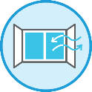  Medium | - Take regular breaks to control the risk of virus concentration build up. | Staff | On-going good practice
 |  | Handling Goods/Materials  - Increased frequency of handwashing and surface cleaning across all close contact areas.  - Allocation of equipment and product for the sole use of individual learners.  - Cleaning in place before and following client learner use.  - Sanitiser & wipes provided in all rooms. | 1x5=5  Medium | - Continue to avoid sharing of goods/items/materials and always use sanitisation/wipes provided. Continue to promote good handwashing practices. | All occupants | On-going good practice
 |  | Communication  - Risk assessment available on website and staff intranet for download under the Coronavirus page.  - Pathway document issued to all departments for briefing to staff.  - Regular staff communication via college network and media platforms. | 1x5=5  Medium | - All occupants to follow Covid measures identified within this risk assessment. | All Occupants | On-going good practice

